Multispecies Occupancy Modeling – OR TWS

February 10, 2017

R Set Up Instructions

If you are not familiar with R, but would like to run some of the models discussed in the workshop follow the instructions below and you should be able to run the scripts provided.

1. **Download and install R, RStudio, and JAGS**

Download and install a current version of R from [https://ftp.osuosl.org/pub/cran/](https://ftp.osuosl.org/pub/cran/%20)

Download and install a current version of RStudio (free open source version) from <https://www.rstudio.com/products/rstudio-desktop/>

Download and install a current version of JAGS from <https://sourceforge.net/projects/mcmc-jags/files/JAGS/4.x/> (I suggest downloading “JAGS-4.2.0.exe”)

1. **Download and save the necessary files**

Download the folder “SimpleExample.zip” from the google drive. Extract the folder and save it in a convenient location.

1. **Open RStudio and load the necessary packages**

Launch a new RStudio window. Select File -> Open File and navigate to the “Simple Example” folder you just saved. Select the file “00_Rsetup.R” and click open. The script should open in a new script window RStudio.

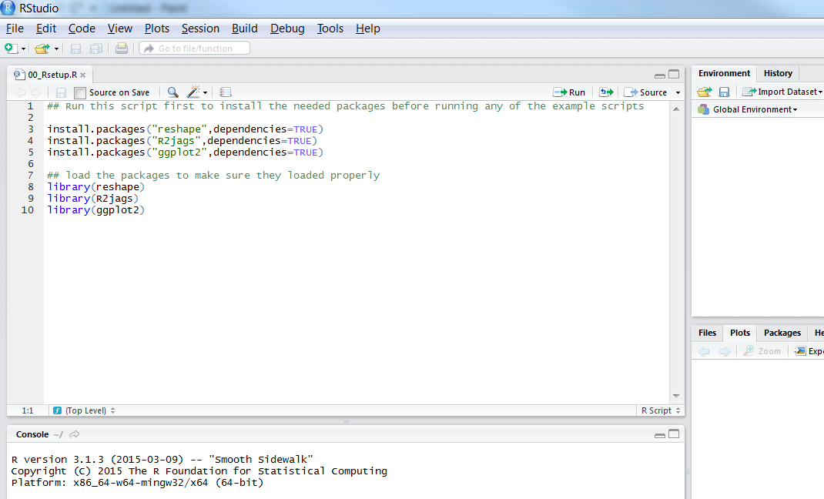

Now that the script is open, place your curser on “install.packages("reshape",dependencies=TRUE)” then click “Run” in the upper right. You should see some text pop up in the Console window below the script, something like but not necessarily identical to the example below.

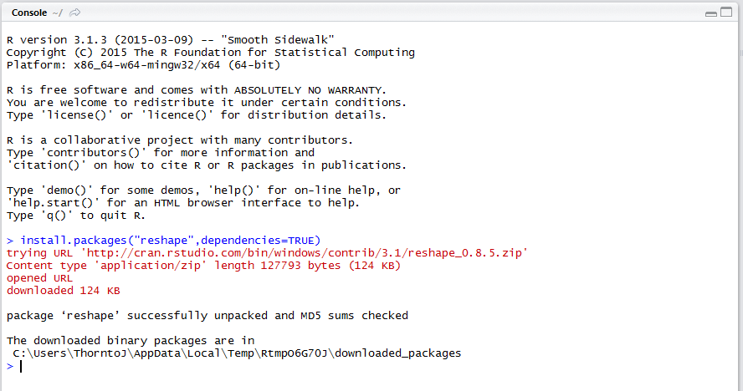

Once the first package has installed, run the next 2 lines of code to install the other packages.

To insure the packages have installed properly, run lines 8-10 (you can highlight all three and then click run). As long as there were no errors you should be ready to run the other scripts.

1. **Open and run the first script**

Open “01_DataSetup.R” by going to File -> Open File and navigating to the correct folder and file. As noted on the first few lines of the script you need to set your working directory to the “SimpleExample” folder. Select Session -> Set Working Directory -> Choose Directory and navigate to the appropriate folder.

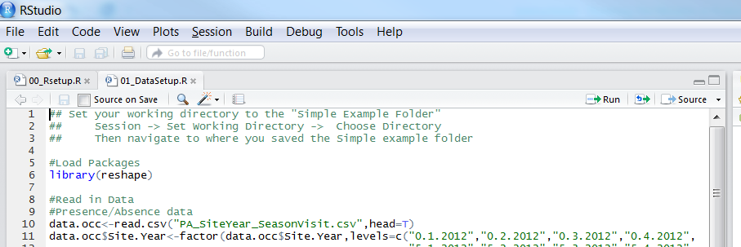

Run this script in the same manner as the Setup script (select a line or several lines of code and hit “Run”).

The result of this script should be that a “.RData” file is saved in the “SimpleExample” folder. This “.RData” file will be used in the next script where we run the JAGS model.

1. **Open and run the other scripts in order**

Once you have successfully opened and run “01_DataSetup.R” you are ready to move on to the other scripts. It is important to run the scripts in order since each script builds on the others.